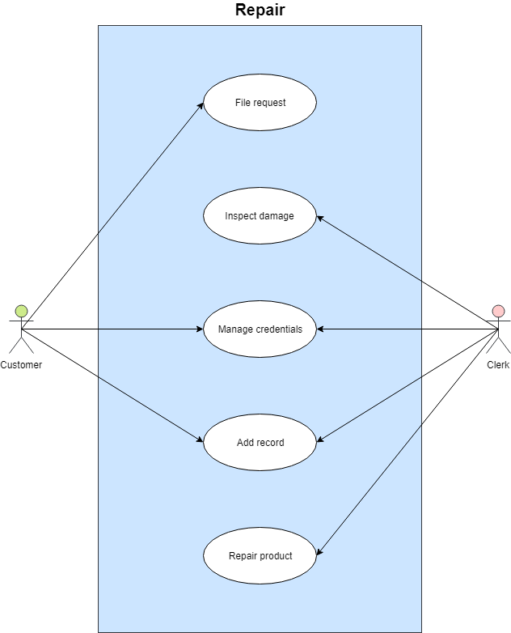

**Brief Description**

This use case allows a customer to repair a TV.

**Flow of Events**

**Activation**

This use case begins when a customer files a request.

**Basic Flow**

1. The customer files a request attaching information about the problem.
2. The clerk sends the TV to a repair team which inspect the damages.
3. Once it is confirmed that the TV is damaged, the customer and clerk manage the credentials such as payment method unless the TV is under warranty repair.
4. The customer pays the clerk.
5. The clerk records the payment into the system.
6. The clerk provides a receipt and estimated time of arrival.

**Alternative Flows**

1. If the customer has insufficient money, the transaction is cancelled until further notice or until it can be paid for.
2. If the TV is not repairable, the customer may choose to get a refund under warranty or choose an alternative.
3. If the TV is not under warranty repair, they must pay for repair costs.

**Special Requirements**

None.

**Pre-Conditions**

The customer must be under warranty to be eligible for a refund or free repair.

**Post-Conditions**

If the use case was successful, the repair details for the customer are updated on the system.

**Extension Points**

None.